Joel Edwards
Course: Java Programming 1
Homework 9
May 22, 2011

9.A)
The shortest and longest word logic reports the first word found that has the shortest or longest length.

Source:

CalculatorGUI.java:
import java.io.BufferedReader;
import java.io.DataInputStream;
import java.io.File;
import java.io.FileInputStream;
import java.io.InputStreamReader;
import java.io.IOException;
import java.util.StringTokenizer;

public class Summarizer
{
// Program Static Methods
public static void main(String[] args)
{
if (args.length < 1) {
usage("No file name supplied.");
}
if (args.length > 1) {
usage("Too many arguments.");
}

File file = new File(args[0]);
if (!file.exists()) {
error("File '" +file+ "' does not exist.");
}
if (!file.isFile()) {
error("Path '" +file+ "' does not refer to a normal file.");
}
if (!file.canRead()) {
error("File '" +file+ "' is not readable.");
}

try {
Summarizer engine = new Summarizer(file);
engine.generateSummary();
System.out.println(engine.getSummary());
} catch (IOException e) {
error("Reading of file '" +file+ "' failed.");
}
}

public static void usage()
{
error(null, true);
}

public static void usage(String message)
{
error(message, true);
}

public static void error(String message)
{
error(message, false);
}

public static void error(String message, boolean showUsage)
{
if ((message != null) && (message.length() > 0)) {
System.out.println("E: " + message);
}
if (showUsage) {
System.out.println("Usage: summarizer <file_name>");
System.out.println(" file_name - the text file to summarize");
}
System.exit(1);
}

// Class Data
private StringBuffer summary;
private File file;

private String longestWord = null;
private String shortestWord = null;
private int lineCount = 0;
private int wordCount = 0;

// Class Methods
public Summarizer(File file)
{
summary = new StringBuffer();
this.file = file;
}

public void generateSummary()
throws IOException
{
BufferedReader reader = new BufferedReader(new InputStreamReader(new DataInputStream(new FileInputStream(file))));
StringTokenizer tokenizer = null;
String line = reader.readLine();
String token = null;
while (line != null) {
tokenizer = new StringTokenizer(line);
lineCount++;
while (tokenizer.hasMoreTokens()) {
token = tokenizer.nextToken();
if ((longestWord == null) || (longestWord.length() < token.length())) {
longestWord = token;
}
if ((shortestWord == null) || (shortestWord.length() > token.length())) {
shortestWord = token;
}
wordCount++;
}
line = reader.readLine();
}

summary.append("Summary for file '" +file+ "'\n");
summary.append(" Lines: " +lineCount+ "\n");
summary.append(" Words: " +wordCount+ "\n");
summary.append(" Shortest Word: '" +shortestWord+ "' (" +shortestWord.length()+ " characters)\n");
summary.append(" Longest Word: '" +longestWord+ "' (" +longestWord.length()+ " characters)\n");
}

public String getSummary()
{
return summary.toString();
}
}

Test Output:
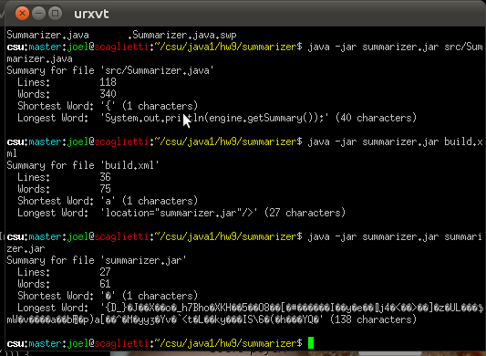

9.B)

???.java:
class ???

Test Output:
Comment..............

